TI Designs
DesignDRIVE Development Kit – A Reference Design for Servo and AC Inverter Drives

Design Overview
The DesignDRIVE Development Kit is a reference design for a complete industrial drive directly connecting to a three phase ACI or PMSM motor. Many drive topologies can be created from the combined control, power and communications technologies included on this single platform. Includes multiple position sensor interfaces, diverse current sensing techniques, hot-side partitioning options and expansion for safety and industrial Ethernet.

The ONE place to create MANY designs for Industrial Drives…

Design Resources
TIDM-SERVODRIVE Design Folder
DesignDRIVE Solutions Tool Folder
DesignDRIVE Development Kit - IDDK Tool Folder
TMS320F28377D Ind-Drive SOC Product Folder
Delfino™ C2000™ Real-time MCUs Product Folder
Isolated Measurement for Motor Drives Tools Folder

Block Diagram
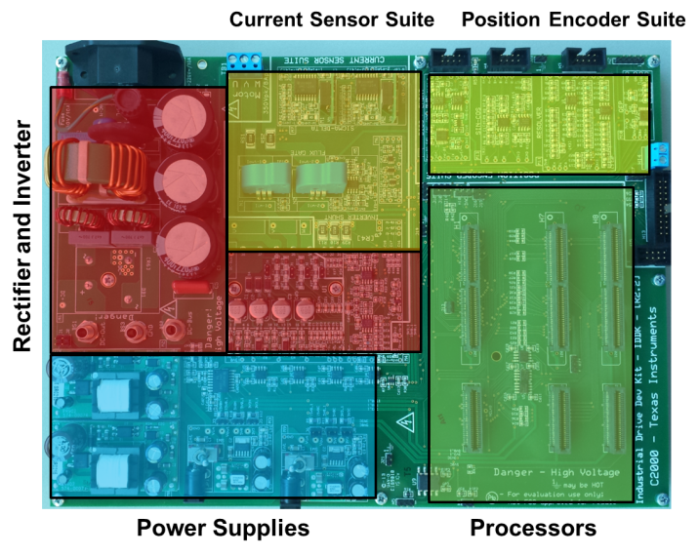
Design Features
- Multiple current sensing topologies
- Configurable isolation partitioning
- High performance real time control
- Multi-protocol encoder interfaces
- Flexible real time connectivity
- Functional safety expansion port

Featured Applications
- Industrial AC Drives
- Industrial Servo Drives
- Industrial Robotics
- Computer Numerically Controlled Machining
- Elevators

Board Image
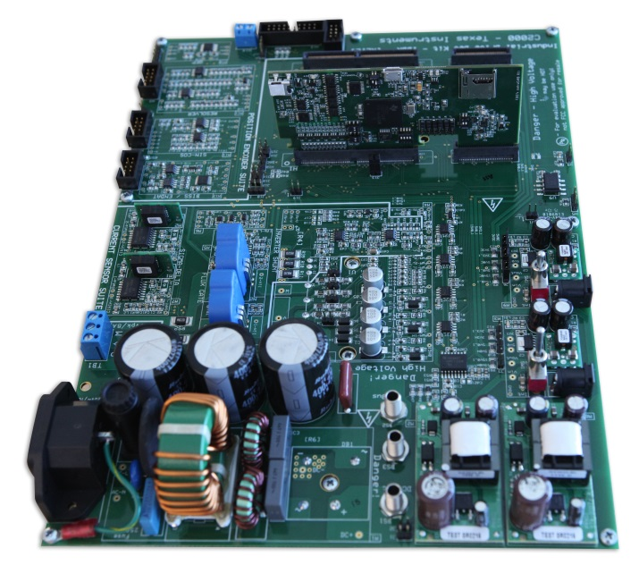

Delta-Sigma Current Sensing Results
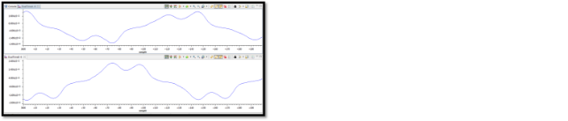

Key System Specifications

Functional Block | Macro Reference | Macro Function
Power Supplies | M2 | Isolated DC-DC converter – 400 V to 15 V
Power Supplies | M3 | DC-Power Supply – Linear Reg 15 V – 5 V to 3.3 V
Power Supplies | M8 | Isolated DC/DC Converter – 400 V to 15 V
Power Supplies | M9 | DC-Power Supply – Linear Reg 15 V – 5 V to 3.3 V
Rectifier and Inverter | M1 | AC Main Power Entry
Rectifier and Inverter | M4 | 3-Phase Inverter
Current Sensor Suite | M5 | Flux Gate – Motor Current Sense Interface
Current Sensor Suite | M6 | Overcurrent Protection
Current Sensor Suite | M7 | Sigma-Delta – Motor Current Sense Interface
Position Encoder Suite | M10 | QEP Interface
Position Encoder Suite | M11 | Resolver Interface
Position Encoder Suite | M12 | EnDat Encoder Interface
Position Encoder Suite | M13 | Sin-Cos Encoder Interface
Processors | Main board | All other functions

Figure 1: Hardware Macros in the IDDK and Their Functions

System Description

The DesignDRIVE kit (IDDK) is a single platform that facilitates development and evaluation of design
solutions for many industrial drive and servo topologies. The IDDK offers support for a wide variety of
motor types, sensing technologies, encoder standards, and communications networks. The IDDK also
offers easy expansion to develop with real-time Ethernet communications and functional safety topologies that enable more comprehensive, integrated system solutions. Based on the real-time control architecture of TI’s C2000™ microcontrollers (MCUs), the kit is ideal for the development of industrial inverter and servo drives used in robotics, computer numerical control (CNC) machinery, elevators, materials conveyance, and other industrial manufacturing applications.

The IDDK offers an integrated-drive design with a full-power stage to drive a 3-phase motor, easing
evaluation of a diverse range of feedback sensing and control topologies. The kit includes a 180-pin
HSEC controlCARD based on the TMS320F28377D C2000 Delfino™ MCU, which integrates dual C28x
real-time processing cores and dual CLA real-time coprocessors that provide 800 MIPS of floating-point performance with integrated trigonometric and FFT acceleration.

The sophisticated sensing peripherals on the TMS320F28377D MCU include sigma-delta filter modules with up to eight input channels, four high-performance 16-bit ADCs, and eight windowed comparators. These peripherals enable the IDDK to support shunt, flux gate/HALL, and sigma-delta current sensing simultaneously. For position feedback, the IDDK leverages integrated MCU support for the resolver and incremental encoder interfaces. In addition, customers can also explore configuration options that place the MCU on either side of the high-voltage isolation barrier.

The board is designed to plug into 110-V/220-V AC mains, deliver up to 8 amps, and to drive motors up to 1 horsepower.

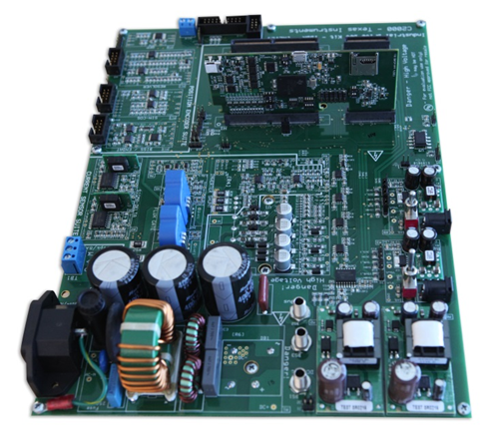
TMS320F2837xD
Real-time Controller, Drive
System-on-Chip
AMC120x
Delta-Sigma Modulator
Analog-to-Digital Converters
Figure 2 DesignDRIVE IDDK Reference Design

TMS320F2837x C2000™ Delfino™ Microcontrollers

The 32-bit Delfino™ series of C2000 Real-time Control microcontrollers brings leading floating-point performance and analog integration to real-time control applications. The Delfino series of microcontrollers simplifies development and delivers high performance for demanding real-time applications. The Delfino series features the new dual-core microcontroller running at 200 MHz on each CPU and also has single-core options running up to 300 MHz.

With a high-performance core, control-optimized peripherals, integrated analog and scalable development platform, the Delfino series of microcontrollers can reduce system cost, increase system reliability and boost performance for applications such as industrial power electronics, power delivery, renewable energy and smart sensing.

Key Features | Key Benefits
- Dual-core C28x at 200 MHz each  - Floating Point Unit  - Trigonometric math unit (TMU)  - Viterbi Complex Unit (VCU)  - Two programmable 32-bit floating-point real-time accelerators (CLAs) on chip  - Up to 1 MB of Flash  - Dual DMA controllers  - High Resolution PWMs (down to 55ps)  - Four 16 bit ADCs, 1 MSPS  - 32-bit QEP and Capture modules  - Programmable PWM Trip | - Leading 32-bit performance for real-time control applications  - Reduced system cost through integrated high performance analog  - Improved application performance and efficiency

AMC1204DW – Delta-Sigma Modulators
- Galvanically isolated current sensing solution
- 16-bit output at 78.1 kSPS
- ±10 A at <0.3% (uncalibrated accuracy)
- 78dB SNR (min)

Block Diagram

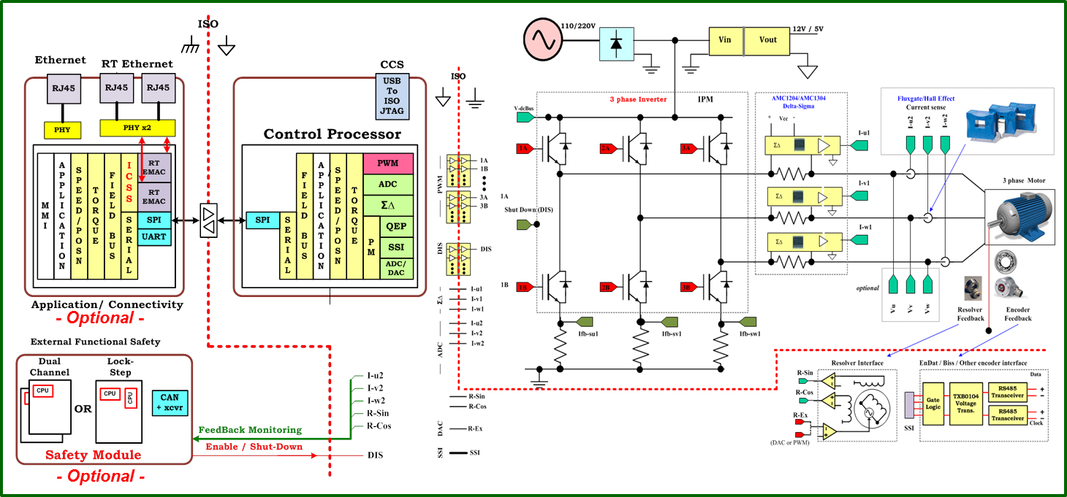

Figure 3 A Block Diagram of TIDM-SERVODRIVE, TMDXIDDK377D

System Design Theory
This design has a low-voltage domain represented by the controller and a high-voltage domain represented by the rectifier and the inverter domain. Please refer to the following documentation for more details:
- DesignDRIVE Development Kit IDDK v2.2 - User’s Guide
- DesignDRIVE Development Kit IDDK v2.2 - Hardware Reference Guide

Getting Started Hardware
As the default configuration, the experiment uses one common HOT GND that connects the control and power circuits. (See entry 4 of Table 3-2, Power Supply Connection Configuration in the DesignDRIVEDevelopment Kit IDDK v2.2 Hardware Reference Guide [SPRUI23].)

For setting up the experimental hardware, perform the following steps:
1. Ensure that jumpers [Main]-J6, [Main]-J7, and [Main]-J8 in front of macro M9, are populated.
2. Ensure that resistors [Main] R8 through R13 are populated.
3. Ensure that GND plane resistors R14 and R15 are mounted. (See Figure 3-12,Various GND Planes onthe Bottom Side of Board and Figure 3-13, Default Connection of Various GND Planes of
DesignDRIVE Development Kit IDDK v2.2 Hardware Reference Guide [SPRUI23].)
4. Unpack the TMDXCNCD28377D control card.
5. Slide the card into the connector slot of [Main]-H1. (Push down using even pressure on both ends of
the card until it cannot slide further. To remove the card, spread open the retaining clips and pull the
card out, applying even force at the edges.)
6. Connect a USB cable to connector J1 on the control card. (The control card isolates the JTAG signals
between the C2000 device and the computer. LED D2 on the control card should light.)
7. Ensure that toggle switch [M9]-SW1 is in the Int position.
8. Connect an isolated 15-V DC-power supply to [M9]-JP1.
9. Turn on toggle switch [M9]-SW1. ([M9]-LD1 should turn on.

NOTE: More LEDs on the control card light up. These LEDs indicate that the control card is
receiving power from the board. Connect the motor to the [Main]-TB1 terminals only after finishing the first incremental build

10. Apply the DC-bus power only when the guide instructs.
Two options exist to get DC-bus power:
• To use an external, variable DC-power supply, do the following:
(a) Set the power-supply output to zero.
(b) Connect [Main]-BS2 and [Main]-BS3 to the + and – terminals of the DC-power supply,
respectively.
• To use AC-Mains power, do the following:
(a) Connect [Main]-BS1 to [Main]-BS2 using a banana plug cord.
(b) Connect the end of the AC-power cord to [Main]-P1.
(c) Set the output of the variac to zero.
(d) Connect the variac to the wall supply through an isolator.
(e) Connect the other end fo the AC-power cord to the output of the variac.

Getting Started Firmware - Installing Code Composer and controlSUITE
1. If not already installed, install Code Composer v6.x or later from http://www.ti.com/tool/CCSTUDIO
2. Go to http://www.ti.com/controlsuite
3. Run the controlSUITE installer.
NOTE: Allow the installer to download and update any automatically-checked software for C2000.

Please see DesignDRIVE Development Kit IDDK v2.2 - User’s Guide for complete instructions for setting up the project.

Design Files

Schematics
To download the Schematics for each board, see the design files at http://www.ti.com/tool/TIDM-SERVODRIVE.
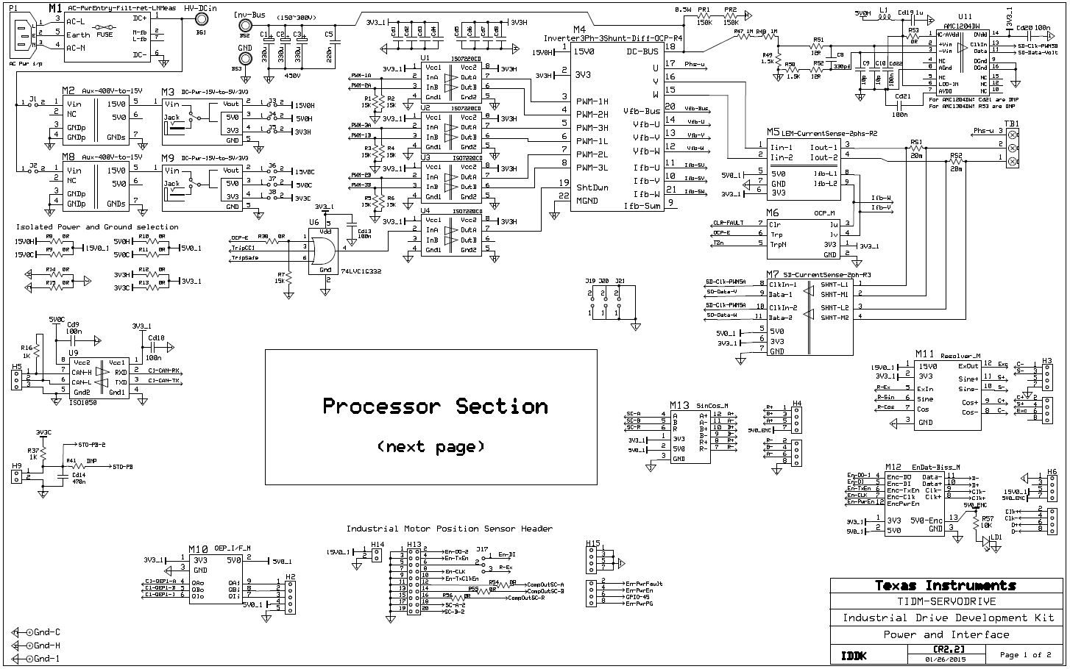

Bill of Materials

To download the Bill of Materials for each board, see the design files at http://www.ti.com/tool/TIDM-SERVODRIVE

Item | # needed per macro | Reference |  | Part Description and Value |  | Manufacturer  Part Number | Digikey Part #
1 | 6 | [Main]-U1,U2,U3,U4, U5, U8 |  | Digital Isolator, Quad 4/0, 25Mbps, ISO7220CD |  | ISO7220CD | 296-26075-5-ND
2 | 1 | [Main]-U7 |  | Digital Isolator, Quad 4/0, 25Mbps, ISO7221ADR |  | ISO7221ADR | 296-21955-2-ND
3 | 1 | [Main]-U6 |  | IC 3-INPUT OR GATE SOT-23-6, SN74LVC1G332 |  | SN74LVC1G332 | 296-18587-1-ND
4 | 1 | [Main]-U9 |  | ISO1050 - IC TXRX CAN 5V 8SOP |  | ISO1050 | 296-24818-1-ND
5 | 1 | [Main]-U11 |  | AMC1204DW, SOIC16 - Isolated SDM |  | AMC1204DW | 296-28557-ND
6 | 3 | [Main]-C1,C2,C3 |  | Electrolytic Capacitors - Leaded 400V, 220uF 25X30 20% |  |  | 1189-2025-ND
7 | 1 | [Main]-C5 |  | Metal Poly Cap. 0.22uF, 400V DC, Lead spacing 0.591" (15.00mm) - EF4224 |  |  | EF4224-ND
8 | 19 | [Main]-Cd1,Cd2,Cd3,Cd4,Cd5,Cd6,Cd7,Cd8, Cd9,Cd10,Cd11, Cd12, Cd13, Cd15, Cd16, Cd17, Cd18, Cd20, Cd22, |  | Cer. Cap - 100nF, 25V, XR7, 0805
9 | 1 | [Main]-Cd21 |  | Cer. Cap - 100nF, 25V, XR7, 0805 (DNP when AMC1204 is used)
10 | 1 | [Main]-Cd14 |  | Cer. Cap - 470nF, 25V, XR7, 0805
11 | 1 | [Main]-Cd19 |  | Cer. Cap - 1uF, 25V, XR7, 0805
12 | 2 | [Main]-C9,C10 |  | Cer. Cap - 10pF, 25V, X5R, 0805
13 | 2 | [Main]-C8 |  | Cer. Cap - 330pF, 25V, X5R, 0805
14 | 7 | [Main]-R1,R2,R3,R4,R5,R6,R7 |  | Res. - 15K, 1%,1/8W, 0805
15 | 1 | [Main]-R57 |  | Res. 10K, 5%, 1/8W, 0805
16 | 12 | [Main]-R24, R31, R32, R33, R35, R38, R39, R42, R45, R54, R55, R56 |  | Res. -0R ,1/8W, 0805
17 | 1 | [Main]-R53 |  | Res. -0R ,1/8W, 0805 (DNP when AMC1304 is used)
18 | 19 | [Main]-R17, R18, R19, R20, R21, R22, R23, R25, R26, R27, R28, R29, R30, R34, R36, R40, R41, R43, R44 |  | DNP : Res. -0R ,1/8W, 0805, Determines isolation settings !! Consult before populating
19 | 2 | [Main]-RS1 , RS2 |  | Res. - 20mOhms, 1%, 3W, 2512 |  |  | CRA2512-FZ-R020ELFCT-ND
20 | 2 | [Main]-PR1, PR2 |  | Power Resistor 150K, 1/2W |  |  | 541-150KVCT-ND
21 | 8 | [Main]-R8,R9,R10,R11,R12,R13,R14,R15 |  | Res - 0E, 1/4W, 1206
22 | 2 | [Main]-R16, R37 |  | Res. 1K ,1/8W, 0805
23 | 2 | [Main]-R47, R48 |  | Res. 1M ,1/8W, 1206, 1%
24 | 1 | [Main]-R49 |  | Res. 1.5K ,1/8W, 1206, 1%
25 | 1 | [Main]-R50 |  | Res. 1.5K ,1/8W, 0805, 1%
26 | 2 | [Main]-R51, R52 |  | Res. 12R ,1/8W, 0805, 1%
27 | 1 | [Main]-L1 |  | INDUCTOR 22UH 13MA 0805 |  |  | 490-4030-1
28 | 1 | [Main]-LD1 |  | LED, green, 0805 Mfr # PG1112H-TR |  | PG1112H-TR | 404-1021-1-ND
29 | 1 | [Main]-P1 |  | CONN AC RECEPT 7MM R/A RND PCB |  |  | Q218-ND
30 |  | [Main]-J1,J2,J3,J4,J5,J6,J7,J8,H9,J10,J12, J13, J14, J15, J16, J19, J20, J21 |  | Standard 0.1'' SIL headers, cut to fit, total needed 1x2
31 |  | [Main]-H5, J17, J9, H10, J18 |  | Standard 0.1'' SIL headers, cut to fit, total needed 1x3
32 | 4 | [Main]-H3, H4, H6, H15 |  | 8 pos keyed 0.1" vertical header 2x4 |  |  | 70246-0801
33 | 1 | [Main]-H13 |  | 20 pos keyed 0.1" vertical header 2x10 |  |  | 70246-2002
34 |  | [Main]-H2 |  | Standard 0.1'' SIL headers, cut to fit, total needed 1x5
35 | 1 | [Main]-TB1 |  | 3 input connector for connecting Motor |  |  | ED1610-ND
36 | 1 | [Main]-H14 |  | Terminals (2 screw) 5.08mm, 7.5mm wide |  |  | ED1975-ND
37 | 3 | [Main]-H1, H7, H8 |  | 180 pin (120 + 60) HSEC8 socket, samtec Mfr # HSEC8-130-01-L-DV-A & HSEC8-160-01-L-DV-A-BL |  | HSEC8-130-01-L-DV-A & HSEC8-160-01-L-DV-A-BL | SAM8081-ND & SAM8084-ND
38 | 3 | [Main]-BS1,BS2,BS3 |  | Banana Connector and Screws |  |  | 501-1115-ND
39 | 1 | M1-C1 |  | CAP FILM 0.047UF 760VDC RADIAL |  |  | 495-3972-ND
40 | 2 | M1-C2,C3 |  | CAP FILM 4n7/2KVdc RADIAL |  |  | 399-5901-nd
41 | 1 | M1-F1 |  | Fuse Holder |  |  | 486-1160-ND
42 | 1 | M1-Fuse-F1 |  | FUSE 250V IEC SLO 5X20MM 10A |  |  | F2425-ND
43 | 1 | M1-RT1 |  | CURRENT LIMITR INRSH 10 OHM 15A - SL32 10015 |  | SL32 10015 | 570-1058-ND
44 | 1 | M1-VAR1 |  | VARISTOR 275V RMS 10MM RADIAL |  |  | 495-1433-ND
45 | 1 | M1-DB1 |  | RECT BRIDGE 35A 600V - GBPC3506W-G |  | GBPC3506W-G | 641-1384-ND
46 | 1 | M1-T1 |  | 8121-RC, CHOKE COMM MODE W/HDR 1mH 20A |  |  | M8916-ND
47 | 2 | M1-L1, L2 |  | INDUCT PWR 7.8UH TH |  |  | 553-1503-ND
48 | 1 | M2-M2 |  | 400V to 15V auxially power supply, PR902 |  | PR902
49 | 1 | M8-M8 |  | 400V to 15V auxially power supply, PR902 |  | PR902
50 | 1 | M3-C1 |  | Cer. Cap - 22u, 25V, X5R, 1206
51 | 1 | M3-C2 |  | Cer. Cap - 10u, 25V, X5R, 1206
52 | 1 | M3-C3 |  | Cer. Cap - 4u7, 25V, X5R, 0805
53 | 1 | M3-C4 |  | Cer. Cap - 0.1uf, 25V, X5R, 0805
54 | 2 | M3-C5,C6 |  | Elec. Cap - 330uf/ 63V, Alum, radial |  |  | P15739CT-ND
55 | 1 | M3-R1 |  | Res. - 330R, 1%, 0.1W, 0805
56 | 1 | M3-R2 |  | Res. - 470R, 5%, 0.1W, 0805
57 | 1 | M3-LD1 |  | LED, green, 0805 |  |  | 404-1021-1-ND
58 | 1 | M3-SW1 |  | Toggle Switch - Miniature, SPDT |  |  | CKN1002-ND
59 | 1 | M3-M1 |  | Power Module - PTH08080 |  | PTH08080 | 296-20432-ND
60 | 1 | M3-U1 |  | LDO - 3.3V - TPS79533 |  |  | 296-13810-1-ND
61 | 1 | M3-JP1 |  | Power jack 2.1 x 5.5 mm |  |  | CP-002AH-ND
62 | 1 | M9-C1 |  | Cer. Cap - 22u, 25V, X5R, 1206
63 | 1 | M9-C2 |  | Cer. Cap - 10u, 25V, X5R, 1206
64 | 1 | M9-C3 |  | Cer. Cap - 4u7, 25V, X5R, 0805
65 | 1 | M9-C4 |  | Cer. Cap - 0.1uf, 25V, X5R, 0805
66 | 2 | M9-C5,C6 |  | Elec. Cap - 330uf, 63V, Alum, radial |  |  | P15739CT-ND
67 | 1 | M9-R1 |  | Res. - 330R, 1%, 0.1W, 0805
68 | 1 | M9-R2 |  | Res. - 470R, 5%, 0.1W, 0805
69 | 1 | M9-LD1 |  | LED, green, 0805 |  |  | 404-1021-1-ND
70 | 1 | M9-SW1 |  | Toggle Switch - Miniature, SPDT |  |  | CKN1002-ND
71 | 1 | M9-M1 |  | Power Module - PTH08080 |  | PTH08080 | 296-20432-ND
72 | 1 | M9-U1 |  | LDO - 3.3V - TPS79533 |  | TPS79533 | 296-13810-1-ND
73 | 1 | M9-JP1 |  | Power jack 2.1 x 5.5 mm |  |  | CP-002AH-ND
74 | 4 | M4-C1,C2,C3,Cd5 |  | Elec. Cap - 100uF, 50V, 20%, SMD |  |  | 565-2133-1-ND
75 | 8 | M4-C4,C5,C6, Cd1,Cd2,Cd3,Cd4,Cd7 |  | Cer. Cap - 2.2uF, 25V, X5R, 0805
76 | 1 | M4-Cd10 |  | Cer. Cap - 2.2uF, 25V, X5R, 1206
77 | 6 | M4-C7,C8,C9,C10,C11,C12 |  | Cer. Cap - 220p, 50V, X7R, 0805
78 | 1 | M4-C13 |  | Cer. Cap - 22nF, 25V, X5R, 0805
79 |  | M4-C15, C16, C17,C18 |  | DNP
80 | 4 | M4-C21-24 |  | Cer. Cap - 47nF, 50V, 5%, 0805
81 | 4 | M4-Cd6,Cd8,Cd9,Cd12 |  | Cer. Cap - 100nF, 50V, XR7, 0805
82 | 1 | M4-Cd11 |  | Cer. Cap - 4.7uF, 25V, X7R, 0805
83 | 3 | M4-D1,D2,D3 |  | US1J-13-F, Diode Ultra Fast SW 600V 1A |  | US1J-13-F | US1J-FDICT-ND
84 | 3 | M4-D4,D5,D6 |  | SMAZ16-TP, Diode Zener 1W 16V SMA |  | SMAZ16-TP | SMAZ16-FDICT-ND
85 | 3 | M4-R1,R2,R3 |  | Res. 10R, 5%, 0.25W, 1206 SMD
86 | 6 | M4-R4,R5,R6,R7,R8,R9 |  | Res. 120R, 5%, 0.25W, 0805
87 | 3 | M4-R10,R11, R39 |  | Res. - 20mOhms, 1%, 3W, 2512 |  | 2512 | CRA2512-FZ-R020ELFCT-ND
88 | 8 | M4-R47-R50, R12, R31, R58, R59 |  | Res. - 0R, 5%, 0.1W, 0805
89 | 1 | M4-R13 |  | Res. - 100R, 1%, 1/8W, 0805
90 | 6 | M4-R14,R16,R17,R33,R34,R41 |  | Res. - 221R, 1%, 1/8W, 0805
91 | 3 | M4-R15,R30,R46 |  | Res. - 300R, 1%, 1/8W, 0805
92 | 4 | M4-R19,R22,R25,R36 |  | Res. - 300K, 1%, 1/3W, 1206 SMD
93 | 7 | M4-R18,R29,R32,R35,R40,R42,R54 |  | Res. - 2K, 1%, 1/8W, 0805
94 | 6 | M4-R43-45, R51-53 |  | Res. - 22K, 1%, 1/8W, 0805
95 | 4 | M4-R20,R23,R26,R37 |  | Res. - 820K, 1%, 1/4W, 1206
96 | 4 | M4-R21,R24,R27,R38 |  | Res. - 9.09K, 1%, 1/4W, 1206
97 | 2 | M4-R28,R56 |  | Res. - 2.7K, 1%, 1/8W, 0805
98 | 2 | M4-R55,R57 |  | Res. - 29.4K, 1%, 1/8W, 0805
99 | 1 | M4-U1 |  | PS21765, MOD IPM 600V 20A MINI DIP |  | PS21765 | 835-1037-ND
100 | 1 | M4-U2 |  | 1.8V Voltage Reference Chip, REF3318AIDBZT SOT23-3 |  | REF3318AIDBZT | 296-22637-1-ND
101 | 2 | M4-U3, U4 |  | OPA2350, CMOS Dual Opamp 8-Soic |  | OPA2350 | OPA2350UA-ND
102 |  | M4-J1-4 |  | Standard 0.1'' SIL headers, cut to fit, total needed 1x2
103 | 1 | M4-HS1 |  | Heat sink - 0.25" aluminum plate for board size (10.925" x 8.125")
104 | 1 | M5-Cd1 |  | Cer. Cap - 2.2uF, 25V, X5R, 0805
105 | 5 | M5-Cd2,Cd3,Cd5, C1, C2 |  | Cer. Cap - 100nF, 25V, XR7, 0805
106 | 2 | M5-Cd4, Cd6 |  | Cer. Cap 10nF, 25V, X5R, 0805
107 | 2 | M5-N1,N2 |  | Current Sensor Hall effect, LTS 6-NP / CAS 6-NP |  | LTS 6-NP / CAS 6-NP | 398-1087-5-ND
108 | 1 | M5-U1 |  | OPA2350, CMOS Dual Opamp 8-Soic |  | OPA2350 | OPA2350UA-ND
109 | 4 | M5-R1,R3, R7, R5 |  | Res. - 5K, 1%, 1/8W, 0805
110 | 4 | M5-R2, R4, R6, R8 |  | Res. - 3.3K, 1%, 1/8W, 0805
111 | 2 | M5-R9, R10 |  | Res. - 10R, 1%, 1/8W, 0805
112 | 1 | M6-Cd1 |  | Cer. Cap - 220nF, 16V, X7R, 0603
113 | 2 | M6-Cd2,Cd3 |  | Cer. Cap - 100nF, 50V, XR7, 0603
114 | 1 | M6-Cd4 |  | Cer. Cap - 1uF, 50V, XR7, 0603
115 | 2 | M6-C1,C2 |  | Cer. Cap - 10nF, 50V, X7R, 0603
116 | 2 | M6-R1,R2 |  | Res. - 100R, 5%, 0.1W, 0603
117 | 1 | M6-R3 |  | Res. 1K, 1%, 0.1W, 0603
118 | 1 | M6-R4 |  | Res. - 22K, 1%, 1/8W, 0603
119 | 1 | M6-U1 |  | IC Comparator 8 SOIC -TLV3502AID |  | TLV3502AID | 296-18147-1-ND
120 | 1 | M6-U2 |  | IC 3-INPUT OR GATE SOT-23-6, SN74LVC1G332 |  | SN74LVC1G332 | 296-18587-1-ND
121 | 1 | M6-U3, |  | IC POS-EDGE-TRIG D F-F-8-US8,SN74AUP1G74DCUR |  | SN74AUP1G74DCUR | 296-19761-1-ND
122 | 2 | M7-M1,M2 |  | CONV DC-DC MINI 1W 3KVDC ISOL, DCH010512DN7(5V->12V), DCH010505SN7 (5V->5V) |  | DCH010512DN7 | 296-20638-ND
123 | 2 | M7-U1,U2 |  | IC AMC1204DW -Isolated SDM 16SOIC |  | AMC1204DW | 296-28557-ND
124 | 4 | M7-L1, L2, L3,L4 |  | INDUCTOR 22UH 13MA 0805 |  |  | 490-4030-1
125 |  | M7-D1,D2 |  | Zener Diode 5.6V - DNP
126 | 4 | M7-Cd5,Cd6,Cd7,Cd8 |  | Cer. Cap - 1uF, 25V, X5R, 0805
127 | 4 | M7-Cd1,Cd3,Cd2,Cd4 |  | Cer. Cap - 100nF, 25V, X5R, 0805
128 | 2 | M7-Cd9, Cd10 |  | Cer. Cap - 100nF, 25V, X5R, 0805  (DNP when AMC1204 is used)
129 | 2 | M7-C1,C4 |  | Cer. Cap - 330pF, 25V, X5R, 0805
130 | 4 | M7-C2,C3,C5,C6 |  | Cer. Cap - 10pF, 25V, X5R, 0805
131 | 4 | M7-R2,R3,R5,R6 |  | Res. - 12R, 1%, 1/8W, 0805
132 | 2 | M7-R1,R4 |  | Res. 0R,1%, 1/8W, 0805 (DNP when AMC1304 is used)
133 | 1 | M10-U1 |  | TXB0106PWR, IC 6BIT NON-INV TRANSLTR 16TSSOP |  | TXB0106PWR | 296-23759-1-ND
134 | 2 | M10-Cd1, Cd2 |  | Cer. Cap. 0.1uF, 25V, 0805, X5R
135 | 3 | M10-C1, C2, C3 |  | Cer. Cap. 10nF, 25V, 0805, X5R
136 | 3 | M10-R1, R2, R3 |  | Res. 47K, 5%, 1/8W, 0805
137 | 1 | M11-C1 |  | Cer. Cap - 1u, 25V, X5R, 0805
138 | 1 | M11-C2 |  | Cer. Cap - 47n, 25V, X7R, 0805
139 | 1 | M11-C3 |  | Cer. Cap - 1n2, 25V, X7R, 0805
140 | 1 | M11-C4 |  | Cer. Cap - 4n7, 25V, X7R, 0805
141 | 2 | M11-C5,C6 |  | Cer. Cap - 220p, 25V, X7R, 0805
142 | 4 | M11-C7,C8,C13,C18 |  | Cer. Cap - 1n, 25V, X7R, 0805
143 | 2 | M11-C9,C14 |  | Cer. Cap - 47p, 25V, X7R, 0805
144 | 4 | M11-C10,C11,C15,C16 |  | Cer. Cap - 330p, 25V, X7R, 0805
145 | 7 | M11-C12,C17,C19,Cd1,Cd3,Cd4,Cd6 |  | Cer. Cap - 100n, 25V, X7R, 0805
146 | 2 | M11-Cd2,Cd5 |  | Cer. Cap - 2u2, 25V, X5R, 0805
147 | 2 | M11-L1,L3 |  | Inductor Bead, 60Ohm, 0805
148 | 1 | M11-L2 |  | Res. - 0R0, 0805
149 | 2 | M11-R1,R24 |  | Res. - 47R, 1%, 0.1W, 0805
150 | 2 | M11-R2,R3 |  | Res. - 3K3, 1%, 0.1W, 0805
151 | 2 | M11-R4,R9 |  | Res. - 68K, 1%, 0.1W, 0805
152 | 2 | M11-R5,R7 |  | Res. - 5K1, 1%, 0.1W, 0805
153 | 8 | M11-R6,R8,R13,R14,R19,R20,R22,R23 |  | Res. - 10K, 1%, 0.1W, 0805
154 | 2 | M11-R10,R16 |  | Res. - 47K, 1%, 0.1W, 0805
155 | 4 | M11-R11,R12,R17,R18 |  | Res. - 11K, 1%, 0.1W, 0805
156 | 2 | M11-R15,R21 |  | Res. - 2K, 1%, 0.1W, 0805
157 | 1 | M11-U1 |  | IC OPAMP GP R-R 18MHZ LN OPA2209 8SOIC |  | OPA2209 | 296-27783-1-ND
158 | 1 | M11-U2 |  | IC OPAMP GP R-R 5.1MHZ TLV2772 8SOIC |  | TLV2772 | 296-10677-1-ND
159 | 1 | M11-U3 |  | TLV2771 in SOT23-5 footprint |  | TLV2771 | 296-1347-1-ND
160 | 4 | M12-Cd1-Cd4 |  | Cer. Cap - 100nF , 25V, 0805
161 | 5 | M12-C1-C5 |  | Cer. Cap - 330pF, 25V, X5R, 0805
162 | 3 | M12-R1,R2,R3 |  | Res. - 10R, 5%, 0.1W, 0805
163 | 1 | M12-R4 |  | Res. - 120R, 1%, 0.1W, 0805
164 | 1 | M12-R5 |  | Res. - 47K, 5%, 0.1W, 0805
165 | 2 | M12-R6,R7 |  | Res. - 150K, 5%, 0.1W, 0805
166 | 1 | M12-U1 |  | Voltage Translator, 4 channel, TXB0104 - TSSOP-14 |  | TXB0104 | 296-21929-1-ND
167 | 2 | M12-U2,U3 |  | Transceiver, RS485 Half Duplex, SOIC-8 |  | SN65HVD3088ED | 296-17172-5-ND
168 | 1 | M12-U4 |  | High Side Switch, TPS27082L - SOT-23-6 |  | TPS27082L | 296-35595-1-ND
169 | 3 | M13-C1-C3 |  | Cer. Cap - 10pF, 25V, NPO, 0805
170 | 3 | M13-Cd1-Cd3 |  | Cer. Cap - 100nF , 25V, 0805
171 | 8 | M13-R1-R4,R9,R10,R16,R17 |  | Res. - 20K, 1%, 0.1W, 0805
172 | 6 | M13-R5-R8,R11,R12 |  | Res. - 10K, 1%, 0.1W, 0805
173 | 3 | M13-R13-R15 |  | Res. - 120R, 1%, 0.1W, 0805
174 | 2 | M13-U1,U2 |  | OpAmp OPA2350, SOIC-8 |  | OPA2350 | OPA2350UA-ND

CNCD-0 Item # | QTY | Reference | Value | Part Description and Value | Mfg | Manufacturer  Part Number | Digikey Part #
CNCD-01 | 69 | [CNCD]-A:C1 A:C6-12 A:C14 A:C16-17 A:C20-30 C1-3 C7 C10-14 C43 C45 C48-64 C66 C75-80 C83-89 C95 C97-100 | 100n | CAP CER 16V 10% X7R 0402
CNCD-02 | 1 | [CNCD]-A:C4 | 10n | CAP CER 16V 10% X7R 0402
CNCD-03 | 2 | [CNCD]-C4-5 | 1n | CAP CER 16V 10% X7R 0402
CNCD-04 | 1 | [CNCD]-C46 | 470n | CAP CER 6.3V 10% X5R 0402
CNCD-05 | 2 | [CNCD]-C6 C67 | DNP | CAP CER 16V 10% X7R 0402
CNCD-06 | 2 | [CNCD]-C8-9 | 15p | CAP CER 50V NP0 0402
CNCD-07 | 2 | [CNCD]-A:C18-19 | 27p | CAP CER 50V NP0 0402
CNCD-08 | 1 | [CNCD]-C68 | 33p | CAP CER 50V NP0 0402
CNCD-09 | 4 | [CNCD]-A:C2 C71-72 C74 | 10u | CAP CER 6.3V 20% X5R 0603
CNCD-10 | 4 | [CNCD]-C44 C82 C91 C96 | 2u2 | CAP CER 10V 20% X5R 0603
CNCD-11 | 3 | [CNCD]-A:C5 A:C13 A:C15 | 4u7 | CAP CER 6.3V 10% X5R 0603
CNCD-12 | 24 | [CNCD]-C19-42 | DNP | CAP CER 16V 10% X7R 0603
CNCD-13 | 3 | [CNCD]-C70 C73 C94 | 10u | CAP CER 10V 20% X5R 0805
CNCD-14 | 3 | [CNCD]-C47 C65 C69 | 22u | CAP CER 6.3V 20% X5R 0805
CNCD-15 | 6 | [CNCD]-C15-18 C81 C90 | 2u2 | CAP CER 10V 20% X5R 0805
CNCD-16 | 1 | [CNCD]-C92 | DNP | CAP TANT 20% 1206
CNCD-17 | 1 | [CNCD]-J1 | HEADER_HSEC8-180_EDGE | 180 pin (120 + 60) HSEC8 fingers; mates with samtec connectors
CNCD-18 | 2 | [CNCD]-A:D3-4 | BLUE | LED BLUE 0805 SMD, Clear, 470nm
CNCD-19 | 2 | [CNCD]-A:D2 LD1 | GREEN | LED GREEN 0805 SMD, Diffused, 567nm
CNCD-20 | 2 | [CNCD]-LD2-3 | RED | LED RED 0805 SMD, Diffused, 647nm
CNCD-21 | 1 | [CNCD]-R66 | 200K | RES 1/16W 0.1% 0402 SMD
CNCD-22 | 1 | [CNCD]-R65 | 205K | RES 1/16W 1% 0402 SMD
CNCD-23 | 1 | [CNCD]-R58 | 22K | RES 1/16W 1% 0402 SMD
CNCD-24 | 1 | [CNCD]-R56 | 2K | RES 1/16W 1% 0402 SMD
CNCD-25 | 1 | [CNCD]-R61 | 340K | RES 1/16W 1% 0402 SMD
CNCD-26 | 2 | [CNCD]-R1-2 | 4K7 | RES 1/16W 1% 0402 SMD
CNCD-27 | 1 | [CNCD]-R63 | 75K | RES 1/16W 0.1% 0402 SMD
CNCD-28 | 7 | [CNCD]-A:R7 A:R10 R16 R59 R69-70 R78 | 0 | RES 1/16W 5% 0402 SMD
CNCD-29 | 2 | [CNCD]-A:R3 R72 | 100K | RES 1/16W 5% 0402 SMD
CNCD-30 | 13 | [CNCD]-A:R2 A:R4 A:R6 A:R8 A:R15 A:R17 R26-27 R29 R62 R71 R73-74 | 10K | RES 1/16W 5% 0402 SMD
CNCD-31 | 4 | [CNCD]-A:R5 A:R9 A:R11-12 | 1K | RES 1/16W 5% 0402 SMD
CNCD-32 | 4 | [CNCD]-A:R16 R11 R24-25 | 2K2 | RES 1/16W 5% 0402 SMD
CNCD-33 | 7 | [CNCD]-R5-10 R14 | 39 | RES 1/16W 5% 0402 SMD
CNCD-34 | 1 | [CNCD]-R22 | 510K | RES 1/16W 5% 0402 SMD
CNCD-35 | 2 | [CNCD]-R18-19 | 56K | RES 1/16W 5% 0402 SMD
CNCD-36 | 4 | [CNCD]-A:R1 R12-13 R60 | 680 | RES 1/16W 5% 0402 SMD
CNCD-37 | 4 | [CNCD]-A:R13-14 R15 R28 | DNP | RES 1/16W 5% 0402 SMD
CNCD-38 | 1 | [CNCD]-R21 | 120K | RES 1/10W 1% 0603 SMD
CNCD-39 | 1 | [CNCD]-R23 | 560K | RES 1/10W 1% 0603 SMD
CNCD-40 | 1 | [CNCD]-R17 | 649K | RES 1/10W 1% 0603 SMD
CNCD-41 | 1 | [CNCD]-R20 | 750K | RES 1/10W 1% 0603 SMD
CNCD-42 | 27 | [CNCD]-R30-42 R44-55 R67-68 | 0 | RES 1/10W 5% 0603 SMD
CNCD-43 | 3 | [CNCD]-R75-77 | 100K | RES 1/10W 5% 0603 SMD
CNCD-44 | 4 | [CNCD]-R3-4 R43 R64 | DNP | RES 1/10W 5% 0603 SMD
CNCD-45 | 1 | [CNCD]-R57 | 0 | RES 1/8W 5% 0805 SMD
CNCD-46 | 9 | [CNCD]-A:TP1-2 TP1-7 |  | Via, 20 ID, 40 OD (mil)
CNCD-47 | 1 | [CNCD]-U5 | micro-SD | micro SD Connector+Ejector, 10 (8+2) positions, SMT-top |  | 101-00581-59 | 101-00581-59-1-ND
CNCD-48 | 1 | [CNCD]-A:C31 | 10n | CAP CER 1.5KV 10% X7R 1812 |  | 1812SC103KAT1A | 478-4735-1-ND
CNCD-49 | 1 | [CNCD]-J8 |  | USB micro AB Female USB2.0 |  | 1981584-1 | A97799CT-ND
CNCD-50 | 2 | [CNCD]-A:SW1 SW1 | 218-2LPST | 2xSPST DIP switch SMT, half-pitch |  | 218-2LPST | CT2182LPST-ND
CNCD-51 | 1 | [CNCD]-SW2 | 4xSPST | 4xSPST DIP Switch |  | 281-4LPST | CT2184LPST-ND
CNCD-52 | 1 | [CNCD]-X1 | 20MHz, 20ppm | 20MHz Crystal, 20ppm |  | 7B-20.000MEEQ-T | 887-1303-1-ND
CNCD-53 | 1 | [CNCD]-A:U5 |  | IC EEPROM 2KBIT 3MHZ 8SOIC |  | 93LC56C-I/SN | 93LC56C-I/SN-ND
CNCD-54 | 2 | [CNCD]-L5-6 | 60Ohm | FERRITE 3A 60OHM@100MHz 0805 SMD |  | BKP2125HS600-T | 587-1932-1-ND
CNCD-55 | 2 | [CNCD]-L3-4 | 220Ohm | FERRITE 2A 220OHM@100MHz 0805 SMD |  | BLM21PG221SN1D | 490-1054-1-ND
CNCD-56 | 2 | [CNCD]-SW3-4 | CAS-D20TA | Switch SPDT, 2 position |  | CAS-D20TA | CASD20JCT-ND
CNCD-57 | 1 | [CNCD]-A:X1 | 12 MHz | CRYSTAL 12.000 MHZ 20PF SMD |  | ECS-120-20-30B-TR | XC1118CT-ND
CNCD-58 | 1 | [CNCD]-A:U4 |  | IC USB HS DUAL UART/FIFO 64-QFN |  | FT2232HL | 768-1024-1-ND
CNCD-59 | 2 | [CNCD]-A:L1-2 |  | FERRITE 500MA 600 OHM 0805 SMD |  | HZ0805E601R-10 | 240-2399-1-ND
CNCD-60 | 5 | [CNCD]-A:U6-8 A:U10-11 |  | IC DGTL ISOLATOR 25MBPS 2CH 8SOIC | TI | ISO7220CD | 296-21953-1-ND
CNCD-61 | 1 | [CNCD]-U12 |  | IC OPAMP GP R-R 15MHZ QUAD 14TSSOP | TI | LMP7709MT/NOPB | LMP7709MT/NOPB-ND
CNCD-62 | 6 | [CNCD]-J2-7 | 1x3 HDR | Header Male; 1x3, 2mm pitch |  | M22-2510305 | 952-1312-ND
CNCD-63 | 3 | [CNCD]-A:D1 D1-2 |  | DIODE SCHOTTKY 10V 1A POWERMITE |  | MBRM110ET1G | MBRM110ET1GOSCT-ND
CNCD-64 | 1 | [CNCD]-U16 | NTA7002NT1G | N-channel MOSFET 30V 0.154A |  | NTA7002NT1G | NTA7002NT1GOSCT-ND
CNCD-65 | 6 | [CNCD]-U6-11 | NUP4201MR6T1G | TVS 4-ch Diode Array, 5V breakdown |  | NUP4201MR6T1G | NUP4201MR6T1GOSCT-ND
CNCD-66 | 1 | [CNCD]-U13 |  | IC, Voltage Reference, 3.0V, 0.2%, 14uVpp noise | TI | REF3030AIDBZR | 296-26323-1-ND
CNCD-67 | 1 | [CNCD]-U17 |  | IC, Voltage Reference, 3.3V, 0.2%, 14uVpp noise | TI | REF3033AIDBZR | 296-26324-1-ND
CNCD-68 | 1 | [CNCD]-A:U9 | 3-State Buffer | 3-State Buffer, 2 elements x 4 bits | TI | SN74ALVC244PWR | 296-5136-1-ND
CNCD-69 | 1 | [CNCD]-A:U3 |  | IC GATE NAND QUAD 2INP 14TSSOP | TI | SN74HC03PW | 296-29731-1-ND
CNCD-70 | 1 | [CNCD]-U2 | SN74LVC2G07DBVR | Buffer Line Driver, non-inverting, 32mA | TI | SN74LVC2G07DBVR | 296-13494-1-ND
CNCD-71 | 1 | [CNCD]-A:C3 | 47u | CAP TANT 20% 0805 6.3V |  | TCTP0J476M8R | 511-1682-1-ND
CNCD-72 | 1 | [CNCD]-C93 | 68u | CAP TANT 10V 20% 1206 |  | TLJA686M010R1500 | 478-4925-1-ND
CNCD-73 | 1 | [CNCD]-U1 |  | MCU F2837x 337pin ZWT BGA | TI | TMS320F28377DZWT
CNCD-74 | 1 | [CNCD]-A:U2 |  | IC ESD-PROT ARRAY 2CH SOT-5 | TI | TPD2E001DRLR | 296-21883-1-ND
CNCD-75 | 1 | [CNCD]-U15 | TPS2051BDBVR | High-Side Power Distribution Switch | TI | TPS2051BDBVR | 296-21265-1-ND
CNCD-76 | 1 | [CNCD]-U3 |  | IC SVS Adjustable SON-6/DRY; PushPull; ActiveLow | TI | TPS3895ADRY | 296-29806-1-ND
CNCD-77 | 1 | [CNCD]-U4 |  | IC SVS Adjustable SON-6/DRY; OpenCollector | TI | TPS3897ADRY | 296-29810-1-ND
CNCD-78 | 1 | [CNCD]-U14 |  | IC Dual Step Down Converter, 2.25MHz, 600mA/1A | TI | TPS62420DRC | 296-25650-1-ND
CNCD-79 | 1 | [CNCD]-A:U1 |  | IC LDO REG HI-PSRR 3.3V SOT23-5 | TI | TPS73033DBV | 296-17580-1-ND
CNCD-80 | 1 | [CNCD]-A:J1 |  | CONN RECEPT MINI USB2.0 5POS |  | UX60-MB-5ST | H2959CT-ND
CNCD-81 | 1 | [CNCD]-L1 | 2u2 | Inductor Power 2.2uH 1.0A SMD 20% |  | VLF3010AT-2R2M1R0 | 445-3215-1-ND
CNCD-82 | 1 | [CNCD]-L2 | 3u3 | Inductor Power 3.3uH 0.87A SMD 20% |  | VLF3010AT-3R3MR87 | 445-3216-1-ND

PCB Layout Recommendations
Please refer to the DesignDRIVE Development Kit - IDDK v2.2 Hardware Reference Guide for more information on layout and use considerations.

Layout Prints
To download the Layout Prints for each board, see the design files at http://www.ti.com/tool/DESIGNNUMBER

TOP SILKSCREEN | TOP SOLDER MASK | TOP LAYER | BOTTOM LAYER | BOTTOM SOLDER MASK
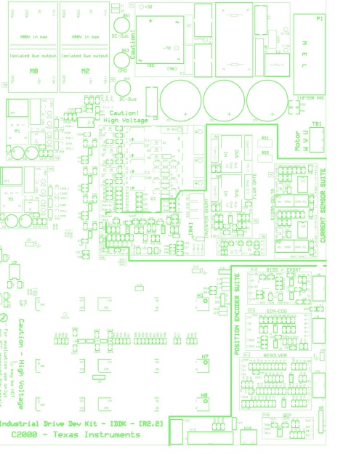 | 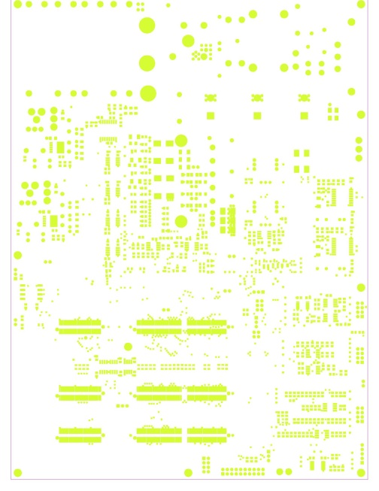 | 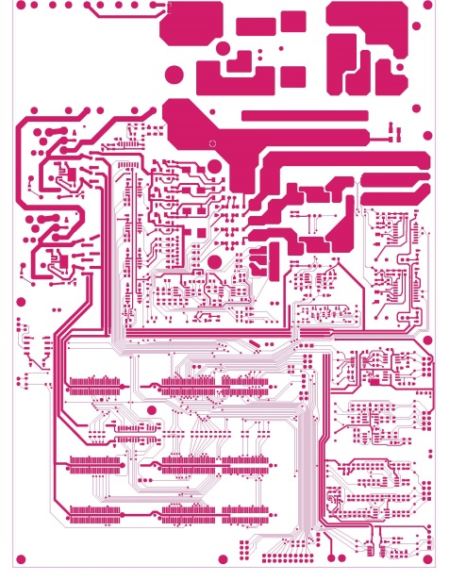 | 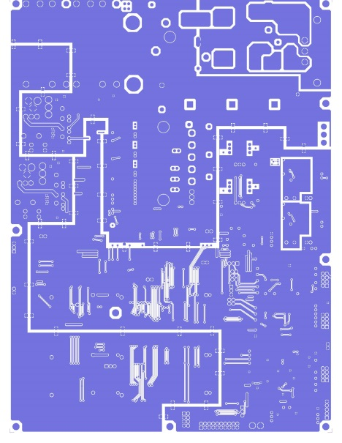 | 

Gerber files
To download the Gerber files for each board, see the design files at http://www.ti.com/tool/TIDM-SERVODRIVE

Software Files
To download the software files for this reference design, please see the link at http://www.ti.com/tool/TIDM-SERVODRIVE and www.ti.com/tool/DesignDRIVE

References

- Texas Instruments Application Report, Noise Analysis in Operational Amplifier Circuits, SLVA043A, 1999
- Texas Instruments WEBENCH® Design Center, http://www.ti.com/webench
- Texas Instruments E2E Community, http://e2e.ti.com/

About the Author

Ramesh Ramamoorthy is a Systems Solutions Engineer at Texas Instruments, where he is responsible for
developing reference design solutions for motor drive end equipment. Ramesh has been a motor drives and power electronics engineer and has extensive experience designing and developing analog / digital controllers for a variety of motor drive applications. He has also developed a few reference designs in HVAC and home appliance industry. He earned his Master of Technology in Electrical Engineering from the Indian Institute of Technology, Madras, India.

Brian Fortman is responsible for the Industrial Drives and Automation market for C2000™ real-time microcontrollers. Brian has 20+ years of experience in marketing, sales and applications and holds a BSEE from the University of Missouri – Rolla.

